**Application and Package Deployment**

**Rei Sula**

**20182283**

**Table Of Contents**

**I. Introduction ................................................... 4**

**A. Overview of SCCM Deployment Tasks ................. 4**

**B. Focus Applications for Deployment .................. 4**

**II. Deployment of Wireshark as an Application .............. 5**

**A. Preparing Wireshark for Deployment .................. 5**

**B. Initiating the Create Application Wizard .............. 6**

**C. Configuring Application Properties .................... 8**

**D. Distributing Content to Distribution Points ........... 9**

**E. Selecting Distribution Points and Strategy .......... 11**

**F. Completing the Deployment Process .................. 14**

**III. Deployment of VLC Media Player ............................ 15**

**A. Introduction to VLC Media Player ...................... 16**

**B. Obtaining and Preparing the Installer .................. 17**

**C. Creating VLC Package in SCCM .......................... 19**

**D. Defining Standard Program Settings ................... 20**

**E. Review and Distribution of VLC Package ............ 21**

**F. Deployment and Monitoring ...............................24**

**G. Finalizing VLC Media Player Deployment ............ 27**

**IV. Deployment of Apache OpenOffice ......................... 27**

**A. Downloading and Creating Package ................... 29**

**B. Detailed Package Configuration .......................... 31**

**C. Establishing Deployment Settings ....................... 33**

**D. Scheduling and Confirmation ............................ 35**

**E. Monitoring Deployment and Verification ............ 36**

**V. Conclusion ...................................................... 37**

**A. Review of Deployed Applications ....................... 37**

**B. Confirmation of Deployment Success .................. 37**

**Introduction**

In this task, I leveraged SCCM (System Center Configuration Manager) to manage software deployments across our network. We focused on three critical applications:

Wireshark: A network protocol analyzer crucial for diagnosing network issues and ensuring security by monitoring network traffic.

VLC Media Player: A versatile media player that supports a wide array of audio and video formats, essential for media-related tasks.

Apache OpenOffice: A free office suite offering word processing, spreadsheets, and presentation tools, serving as an alternative to Microsoft Office.

**Deploying Wireshark as an Application**

Preparing Wireshark for Deployment

Firstly, I downloaded Wireshark's MSI (Microsoft Installer) package, a file format used for installation, storage, and removal of software. The MSI file format is chosen for its reliability in distributing and managing applications in a Windows environment.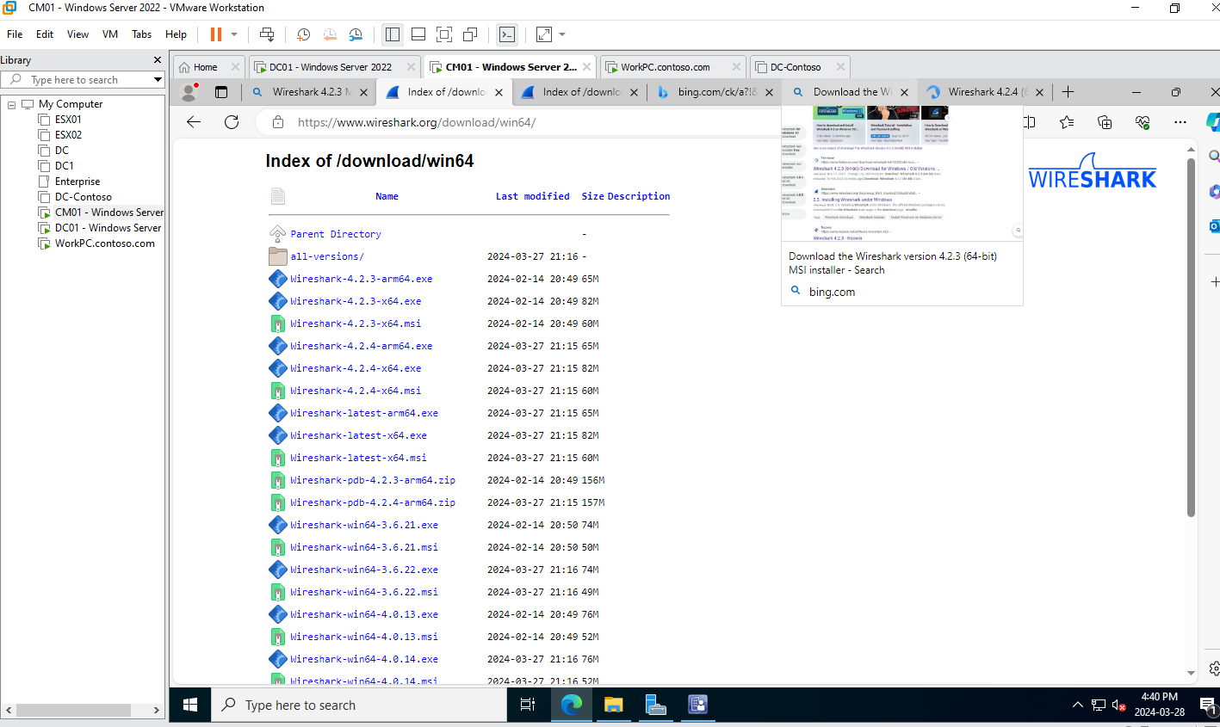

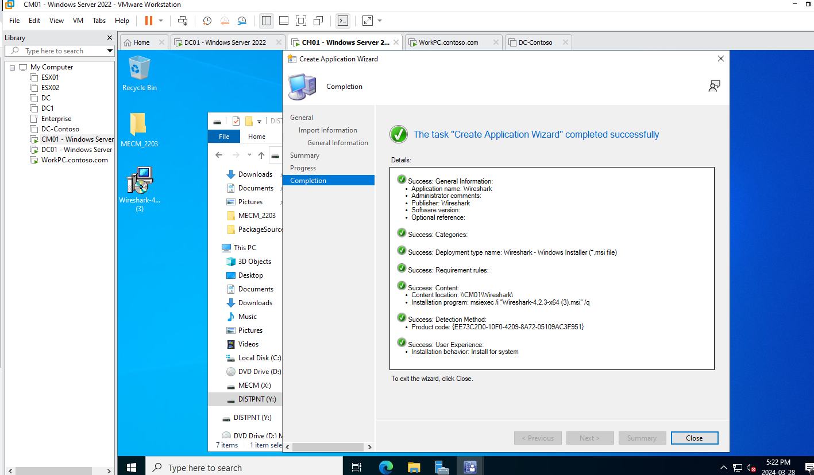Upon downloading the MSI, I moved to the SCCM console. Here, we initiated the 'Create Application Wizard,' designating Wireshark as a new application to be managed. This step is crucial as it informs SCCM about the new software and how it should handle it.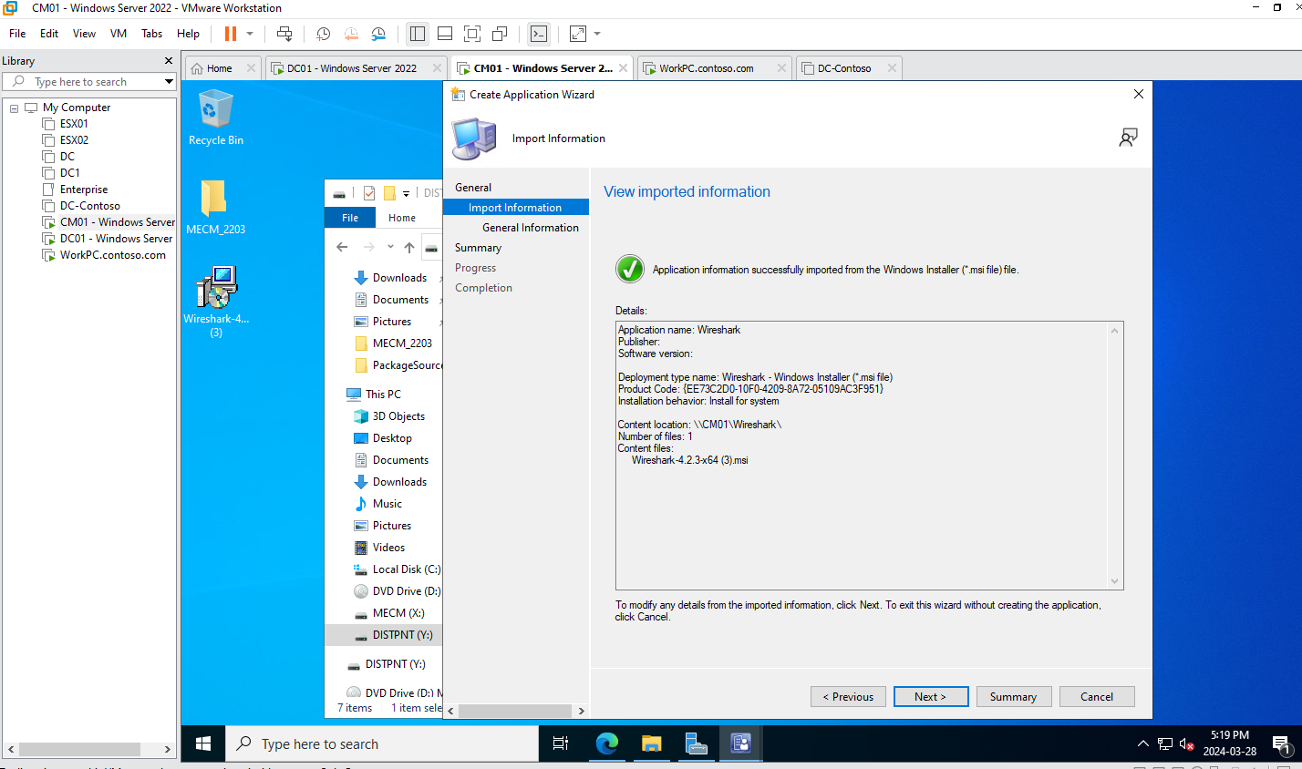

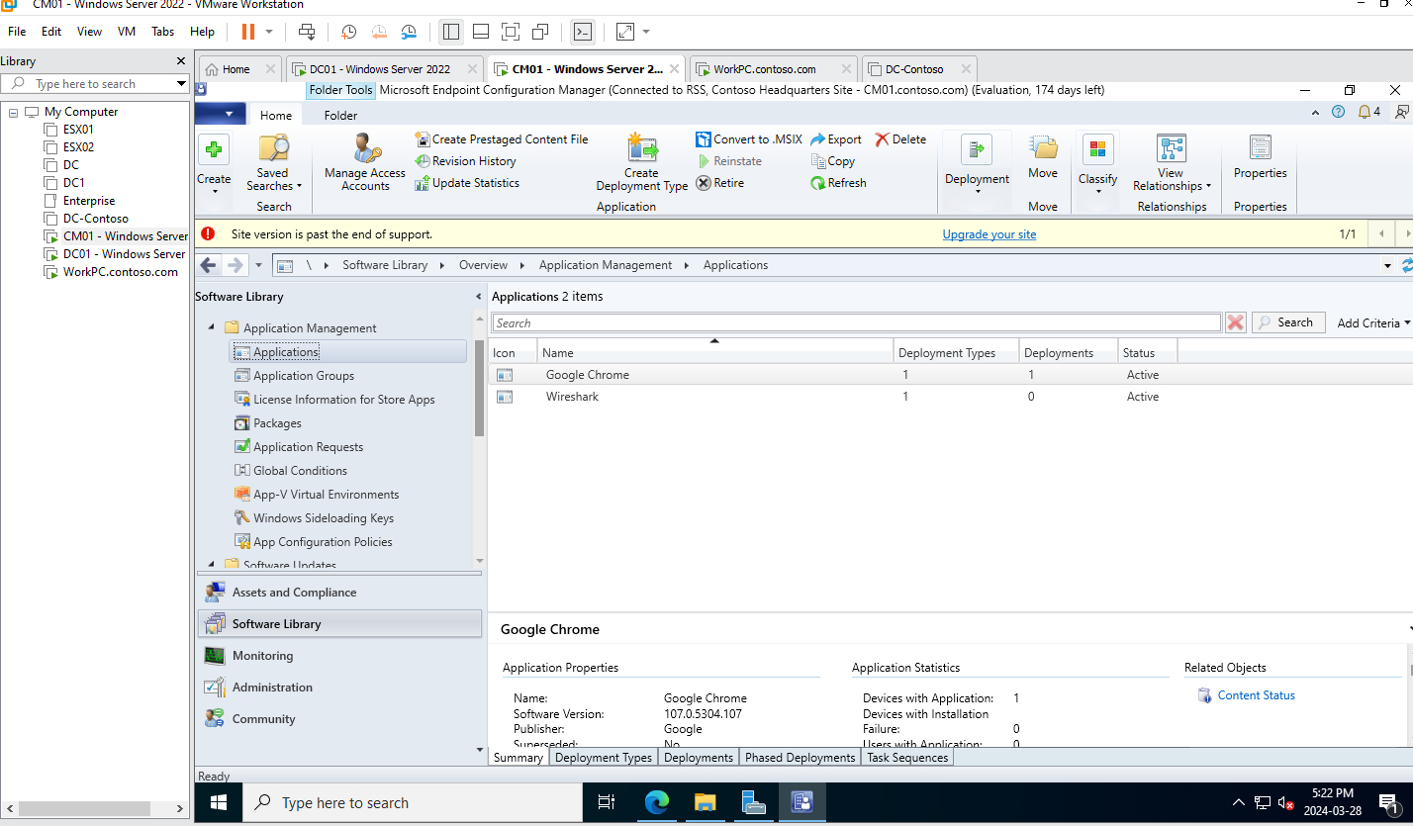

Once Wireshark was recognized as an application within SCCM, detailed in previous screenshots we progressed to configuring its properties. These settings inform SCCM about the application's identity — its name, version, and how it should behave during installation. The 'Deployment Type' defines the installation experience, and the 'Content Location' points SCCM to the network path where the Wireshark installer resides.

The deployment continued as we prepared to distribute Wireshark's content to SCCM 'Distribution Points,' servers that act as storage points for software deployment, displayed in the following screenshots. The specific distribution point group was “Contoso Distribution Points” as shown in the following screenshots. This distribution is an important step, ensuring that the installer is available to all client machines within our network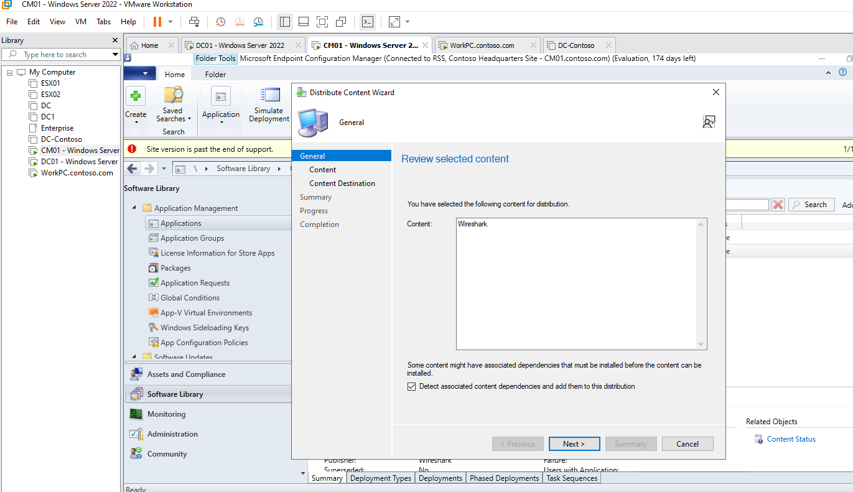

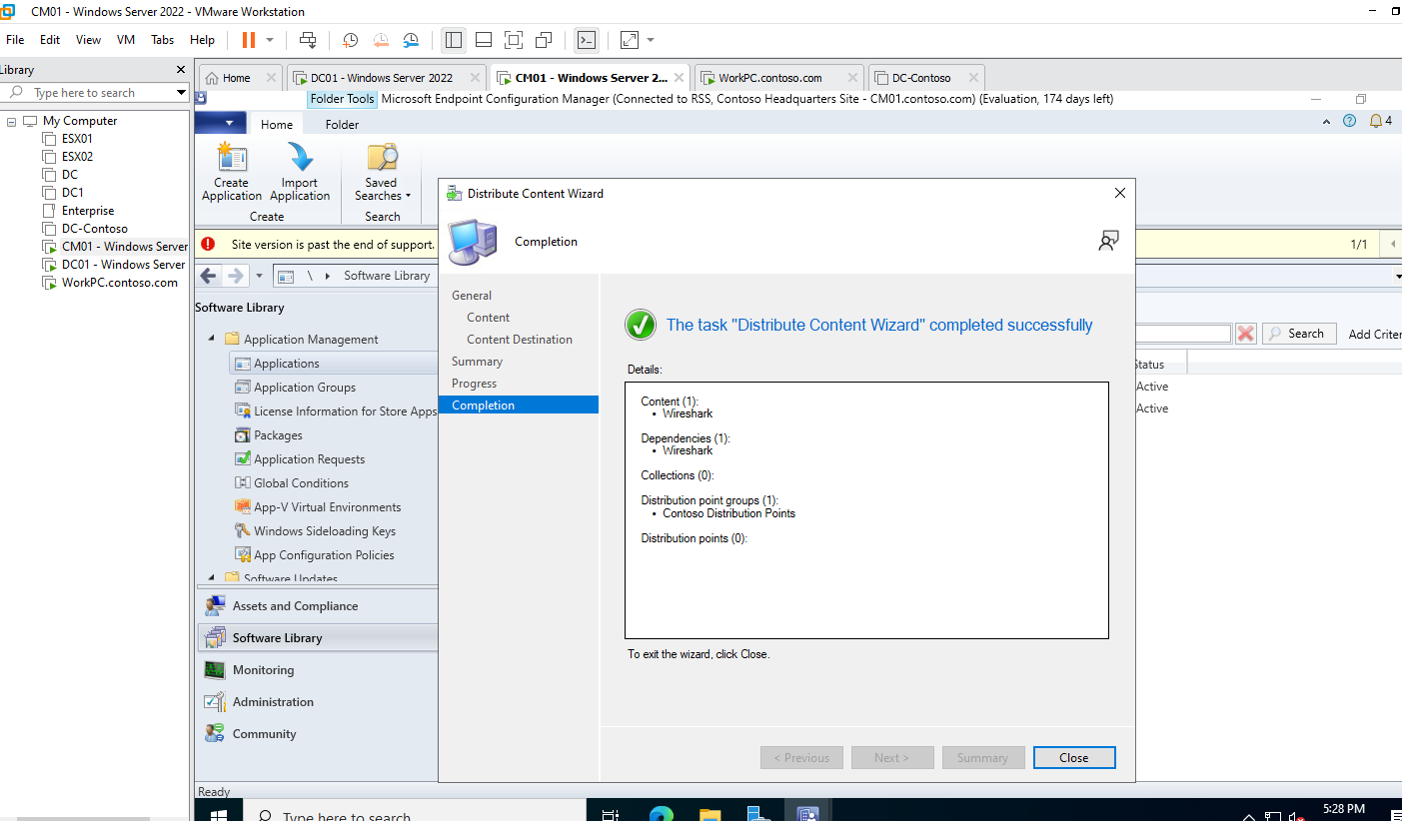

Next, I choose to deploy the Wireshark application by opening the “Deploy Software Wizard” and choosing “My workstations” which is the collection that contain the Client, the windows 10 PC where we are going to test our applications. 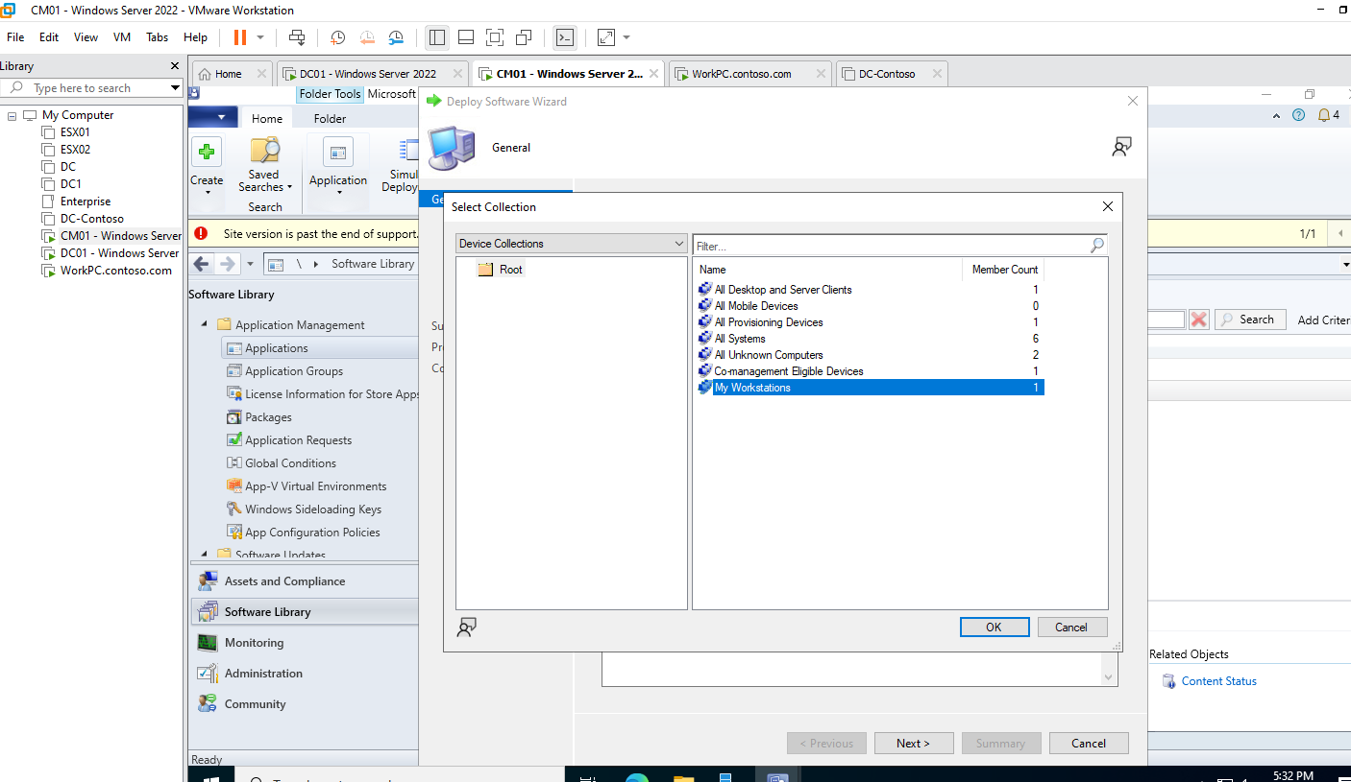

Next, we set the deployment strategy where we chose to deploy Wireshark as a 'Required' application, triggering an automated installation on targeted devices without user intervention. The following screenshots will capture this process in detail.

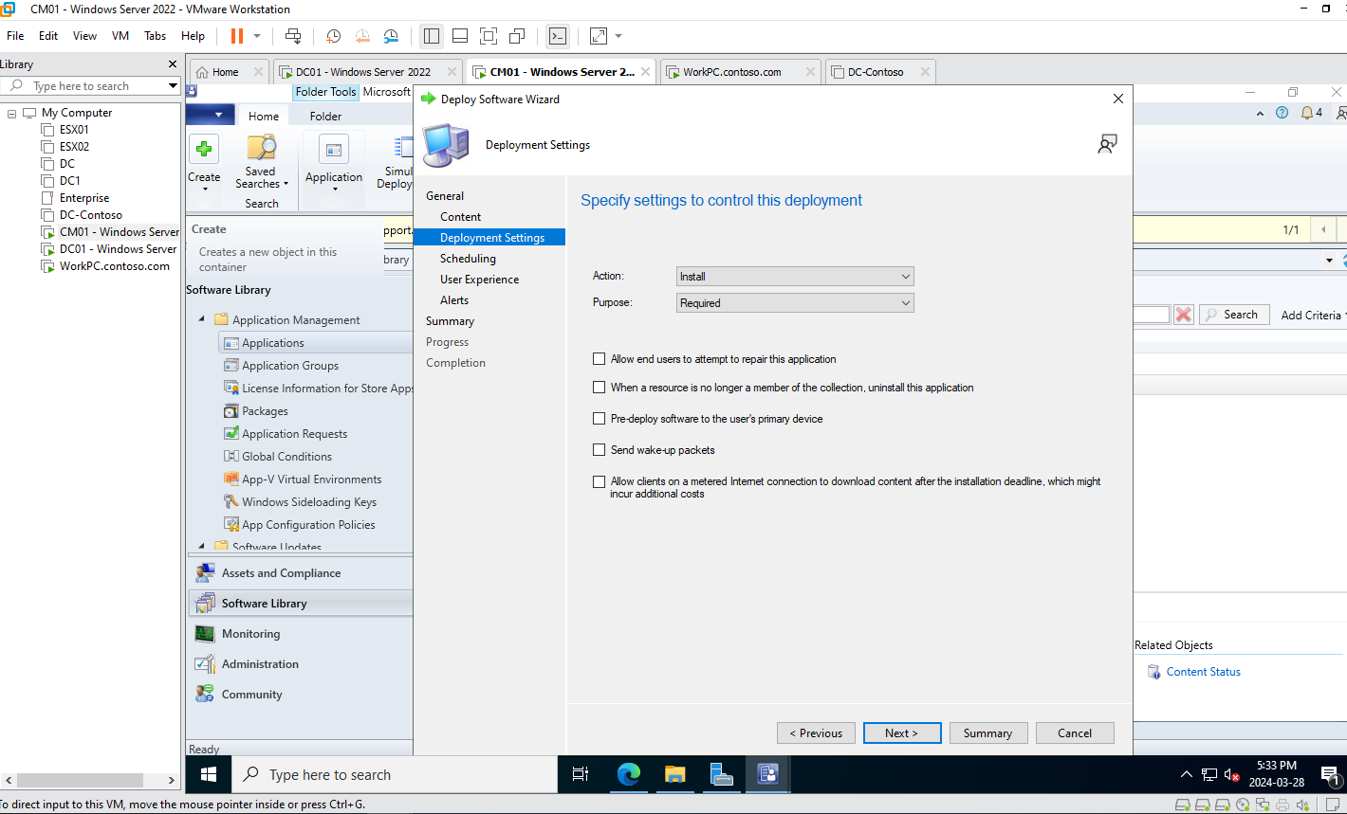

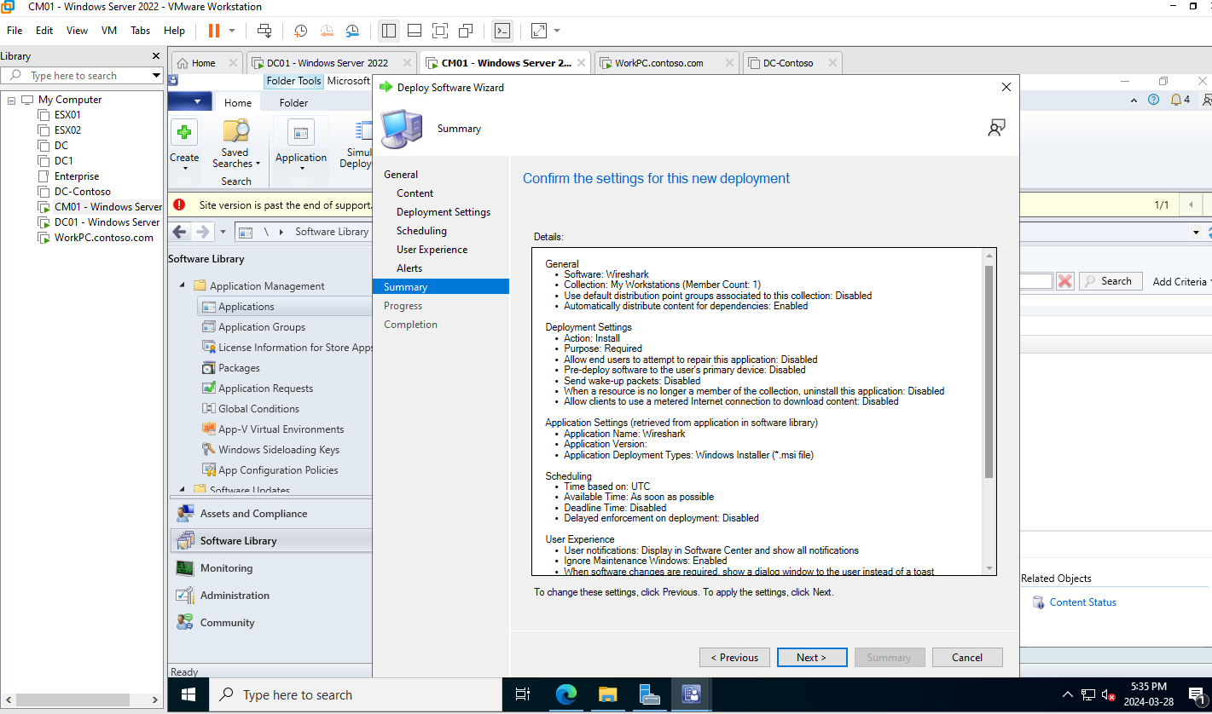

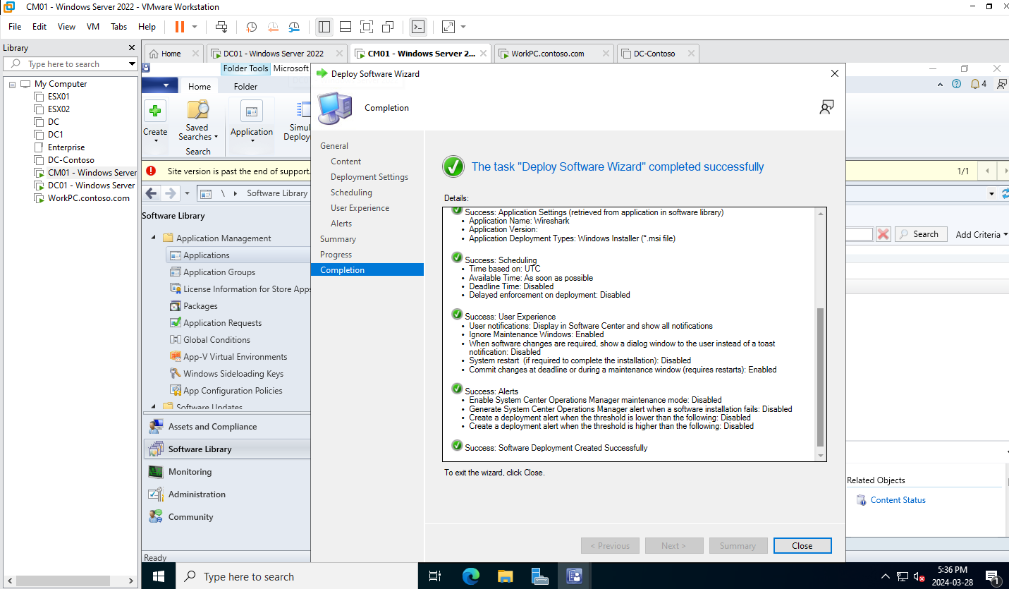

In the last screenshot we can see that the “Deploy Software Wizard” is completed successfully. Now it’s time to check it in the monitoring tab and we can see that the application is right there. The monitoring tab is important in identifying and resolving any issues with ease.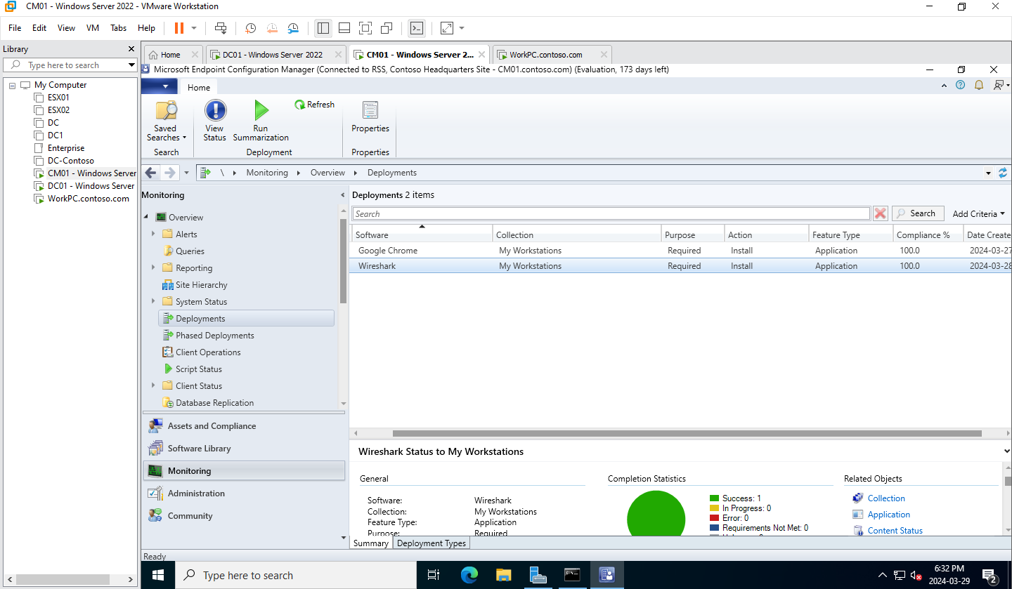

As Wireshark's deployment reached its final stages, the final screenshots prove the completion status. The application was automatically installed in the client without any user intervention. This is because we chose the “required” option earlier in the deployment wizard.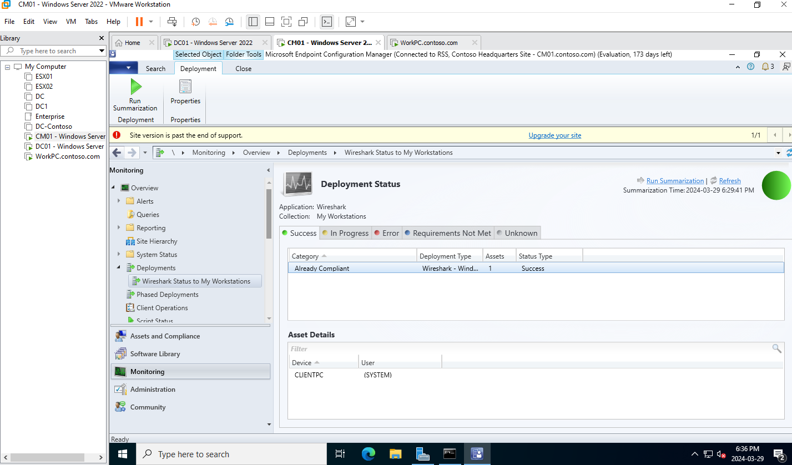

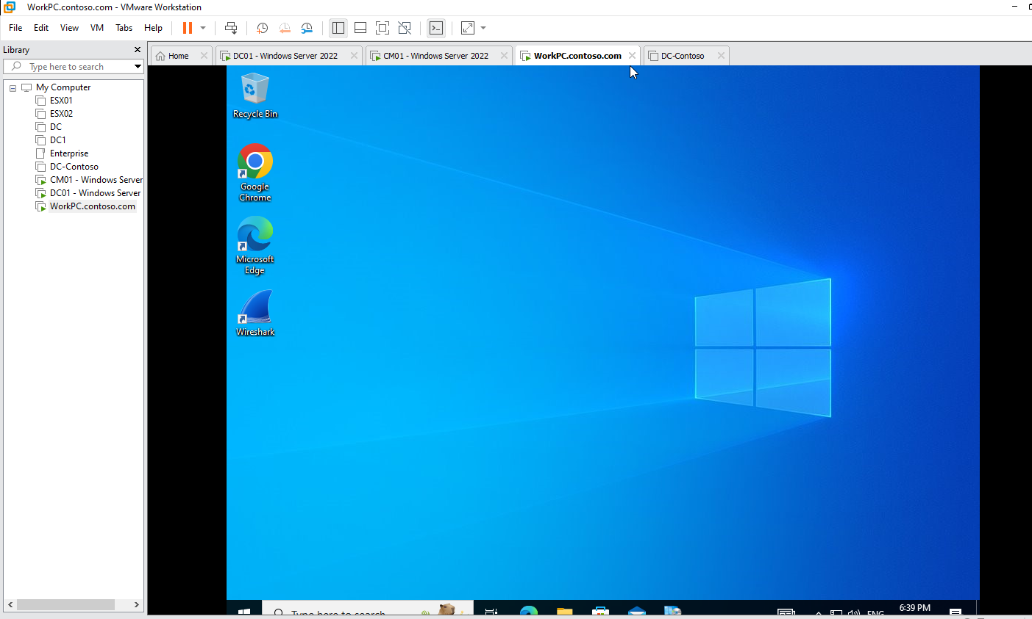

Through a series of steps, we successfully deployed Wireshark across our workstations. Each screenshot captures a phase of the deployment, from initiation and distribution to monitoring and final verification. This process was managed totally through SCCM.

**Deploying VLC Media Player**

VLC Media Player is a highly versatile multimedia player renowned for its ability to play a vast array of video and audio formats. Created by the non-profit organization VideoLAN, VLC is open-source software, which means its source code is available for anyone to view or modify. This feature-rich player supports streaming media and can play content from various sources, including files, physical media, TV capture cards, and network streaming protocols.

The first action in deploying VLC Media Player involved obtaining the correct installer file, which in this case is the "vlc-3.0.20-win64.msi." The MSI file is the standard format for Windows installers, facilitating easy distribution and installation across multiple devices (sc-1).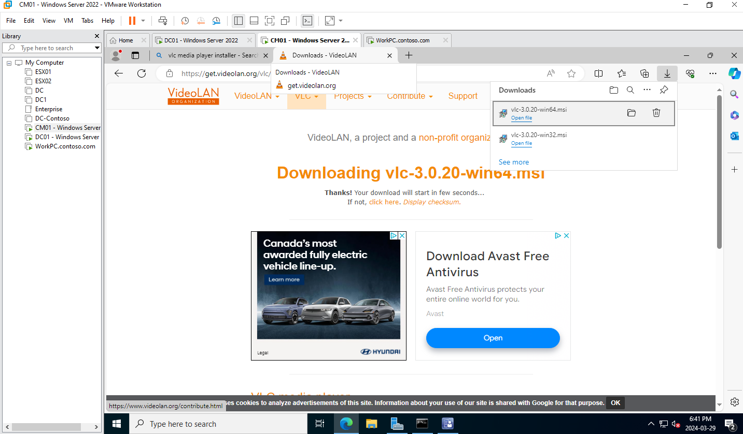

SC-1

We opened the System Center Configuration Manager console, where deployment tasks are managed. Within the 'Software Library', we found the section for 'Packages' which is where VLC as a package will be created and managed (sc-2).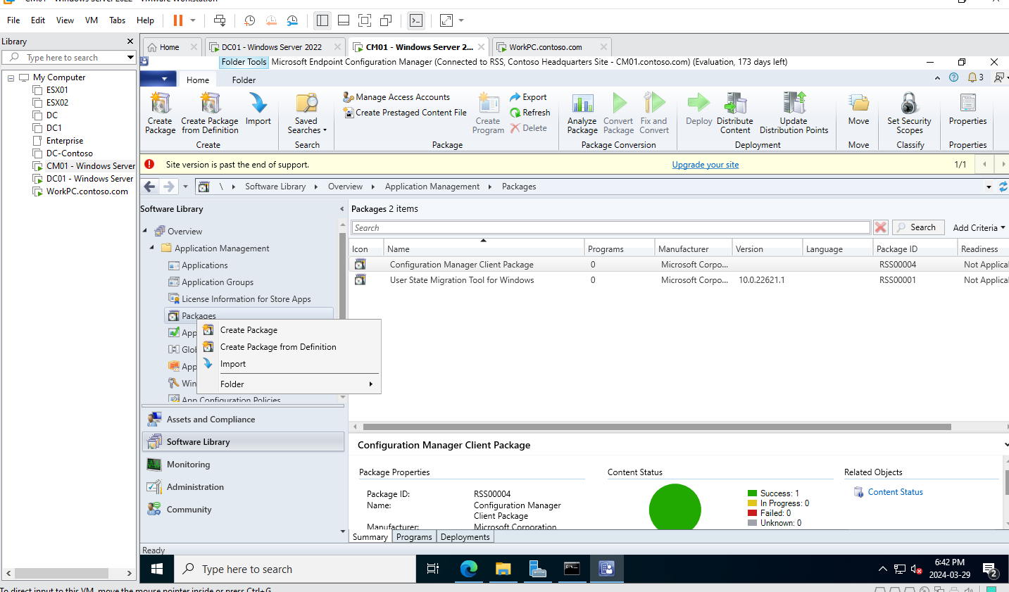

Sc-2

In the 'Create Package and Program Wizard', we entered the details of VLC Media Player. This step involved specifying the name, manufacturer, and whether the package contains source files or not. It’s a pivotal moment where VLC is introduced into the SCCM system (sc-3).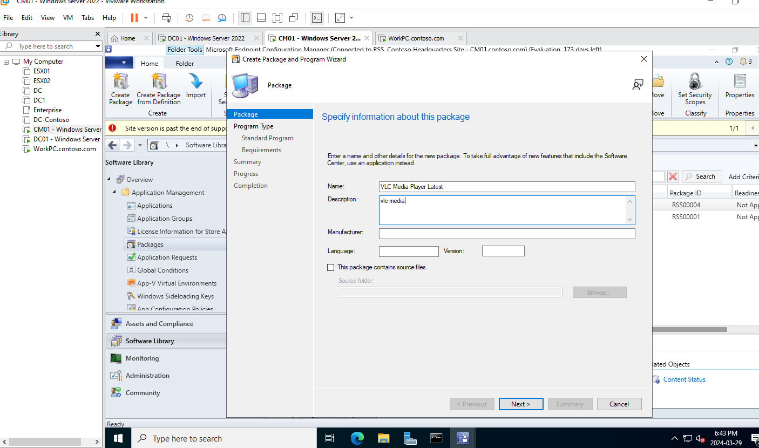

Sc-3

Next, we specified the standard program settings. This included the command line to run for installation ("msiexec /i vlc.msi /qn"), which tells the system how to execute the VLC installer. Here, we can also set the run behavior, such as requiring administrative rights for installation (sc-4)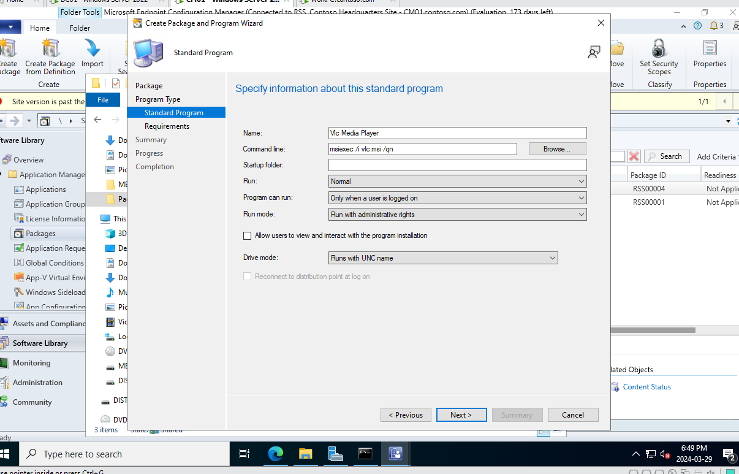

Sc-4

Once the package was defined, we reviewed the settings ensuring everything from the package name to the command line was correctly entered. This review process is essential to catch any potential errors before proceeding. After I checked that there was not any error, I continued and completed the wizard. (Sc-5, Sc-6)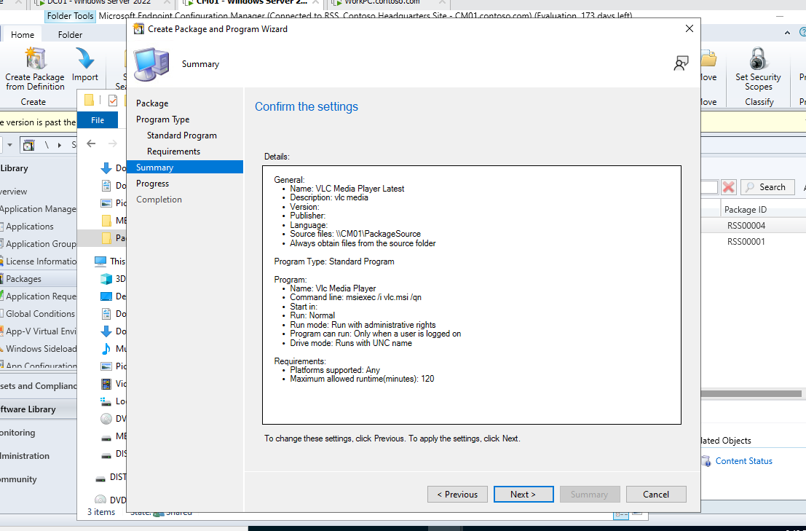

Sc-5

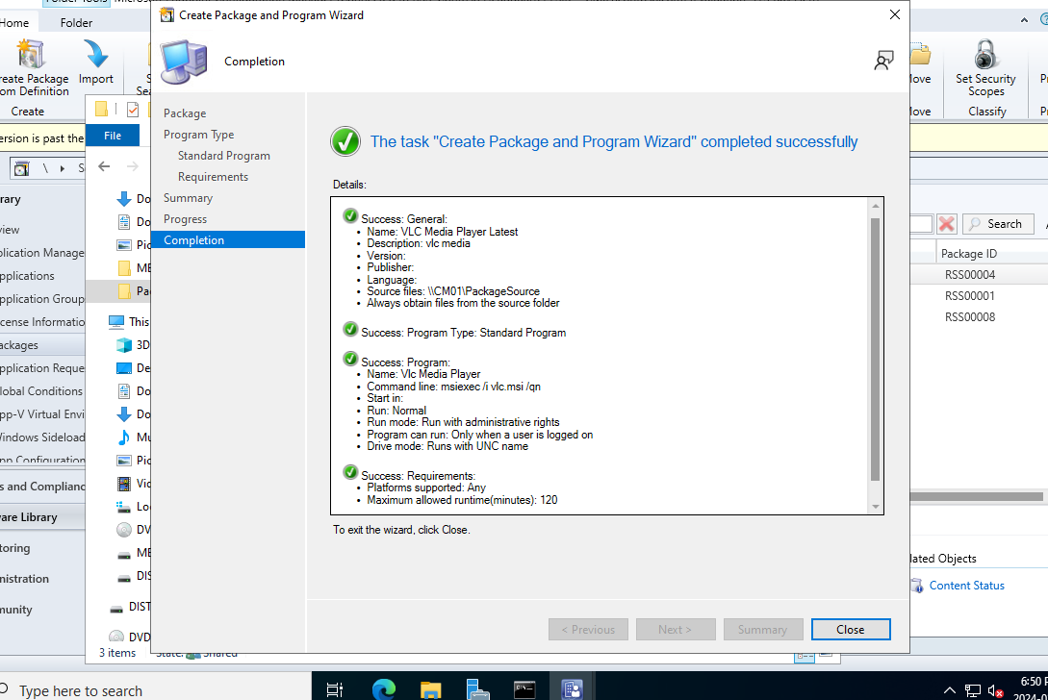

Sc-6

With the package ready, I initiated the 'Distribute Content Wizard'. This is the stage where the VLC package is distributed to SCCM Distribution Points, which are servers that store the content to be installed on client machines (sc-7).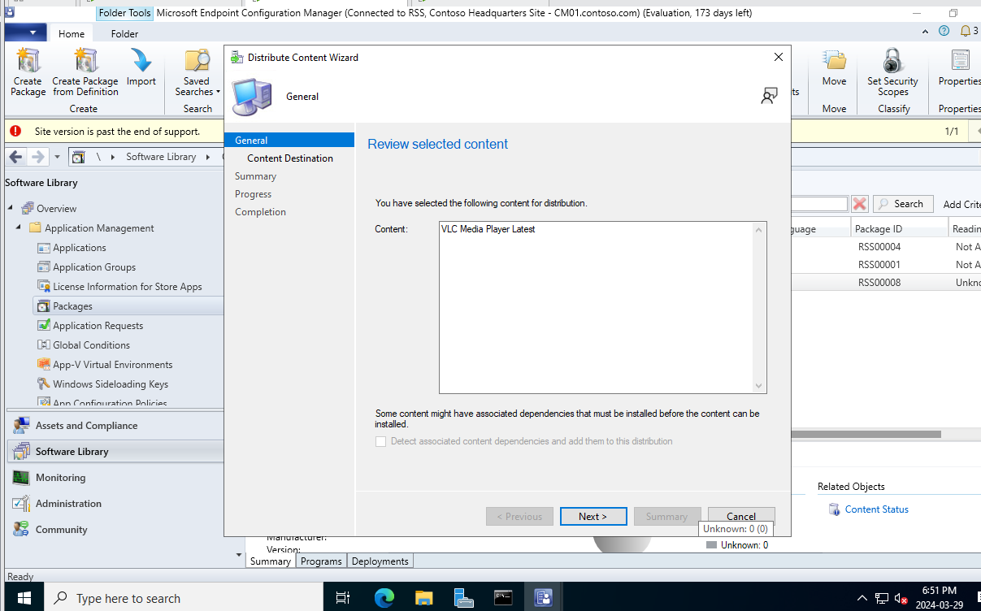

Sc-7

We then selected the specific distribution points for VLC. Distribution points are key in ensuring the software is accessible to the clients within the network (Sc-8)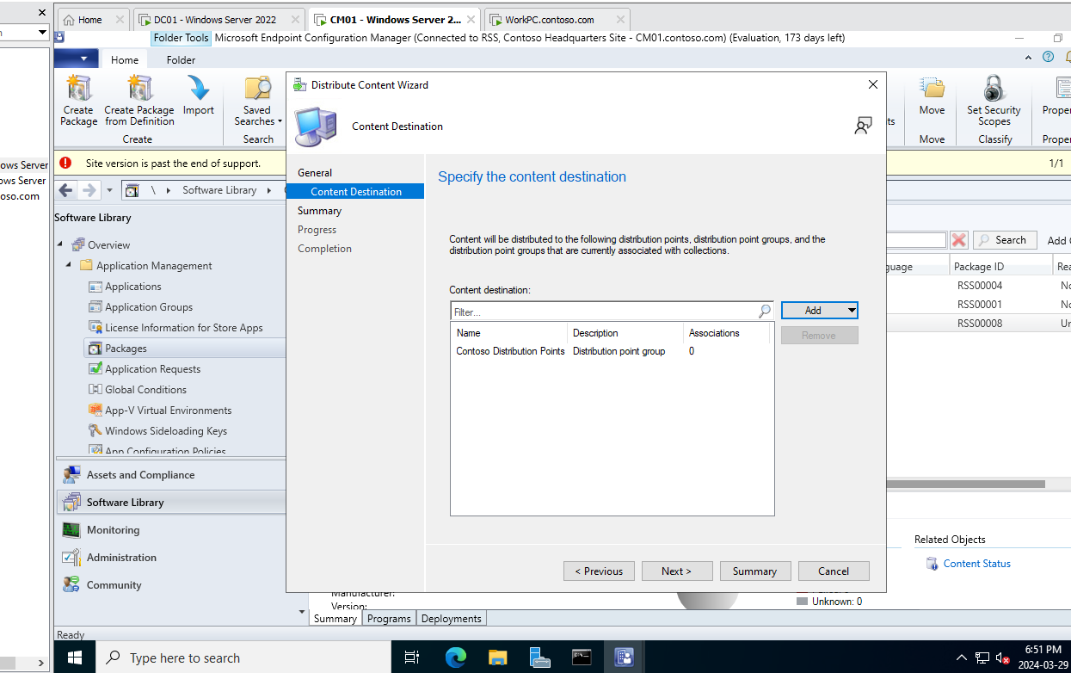

Sc-8

A final confirmation was made to ensure VLC Media Player's content is ready for distribution. It's the moment before the software is virtually pushed to the available distribution points. (Sc-9)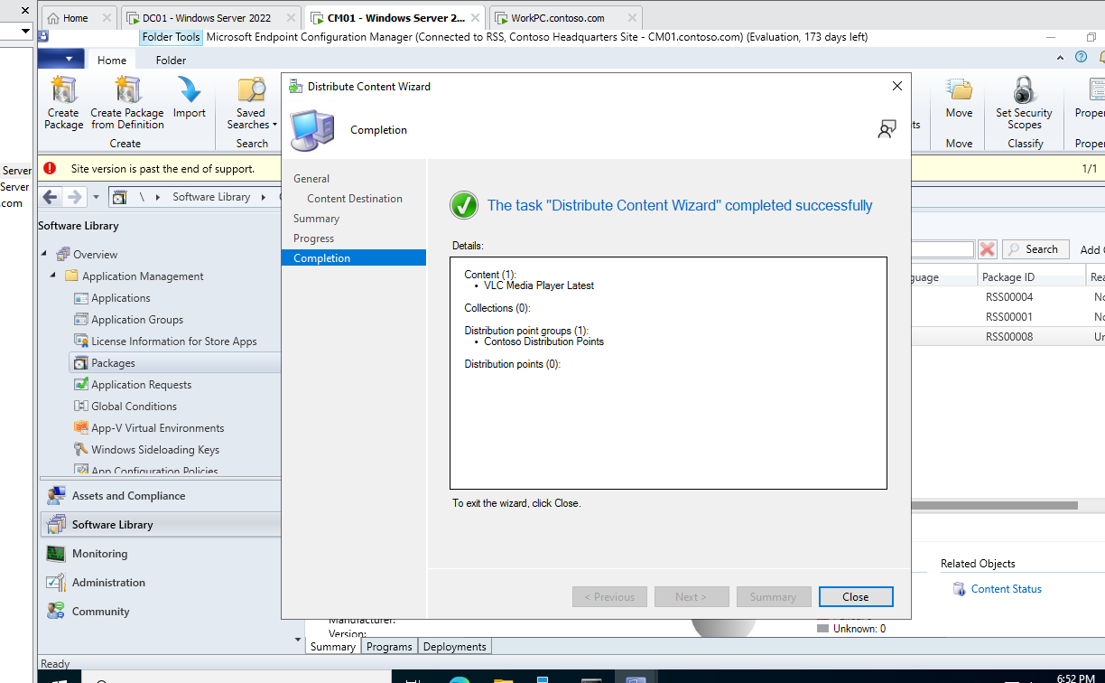

Sc-9

Through the 'Deploy Software Wizard', I began the process of deploying the VLC package. The actual deployment process begins here, specifying general information about the deployment, such as the collection of devices targeted and whether the software should be installed automatically or made available for users to install. As stated in the instructions I only made it available for users to install if they wanted, by choosing the option available rather than required, so I didn’t download it automatically as we did with Wireshark. (Sc-10, Sc-11)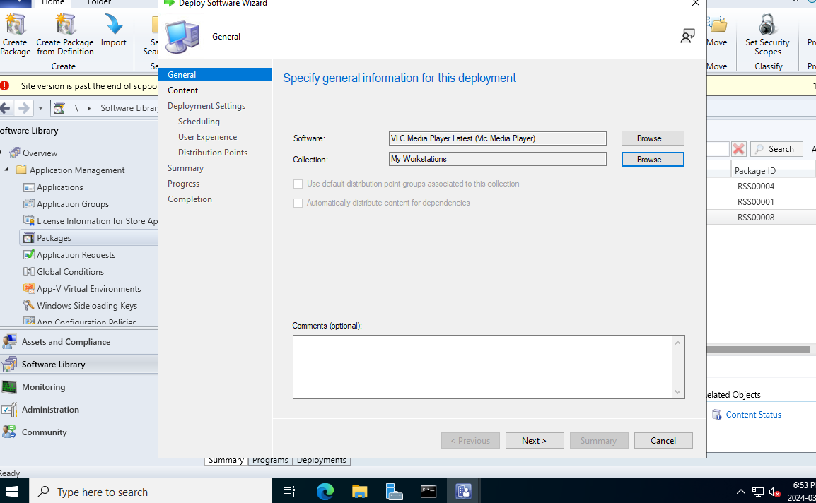

Sc-10

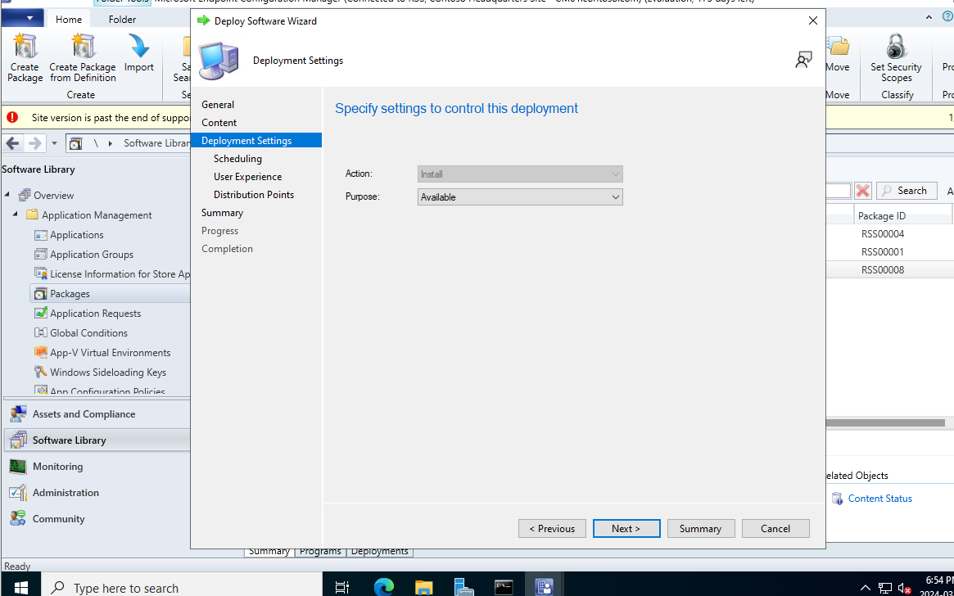

Sc-11

The final steps include confirming all deployment settings and summarizing the process, ensuring that we've allowed for proper end-user notification and handling for the installation. (sc-12, sc-13)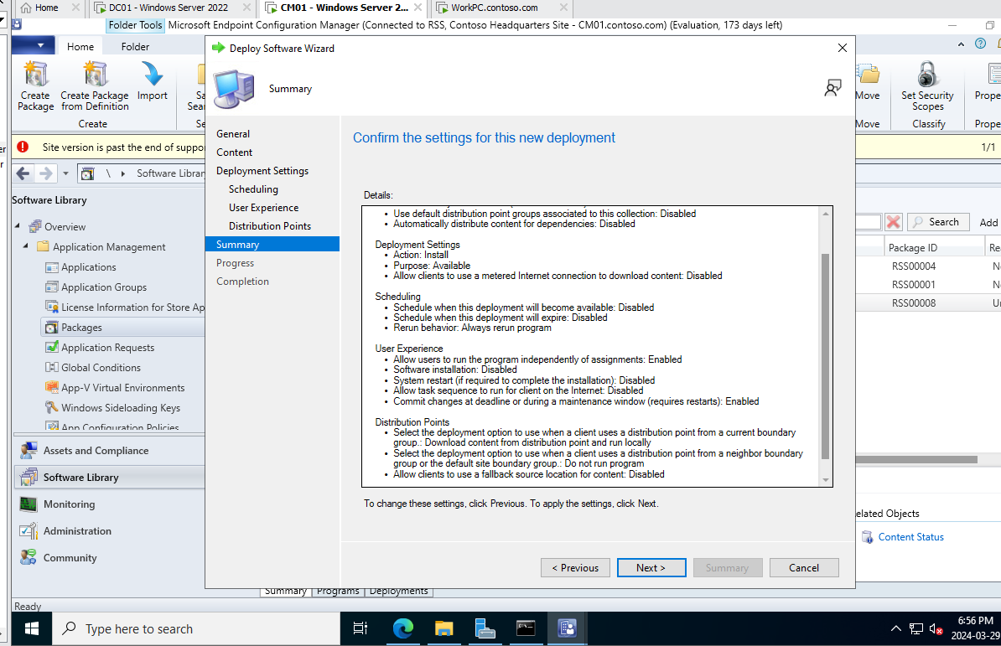

Sc-11

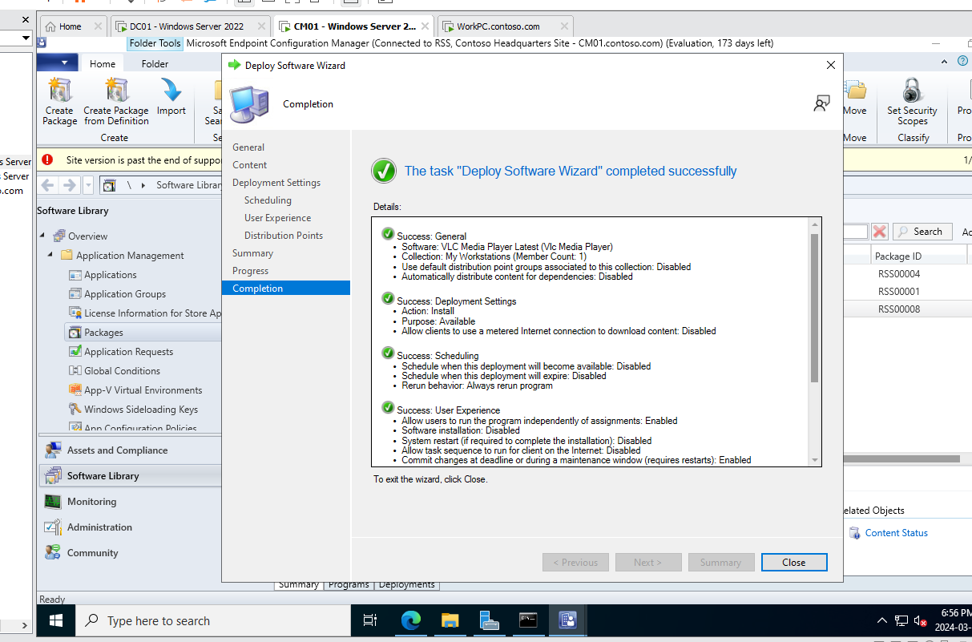

Sc-12

After deployment, I monitored the progress using SCCM's 'Monitoring' tab, checking the status for any errors or completion rates.

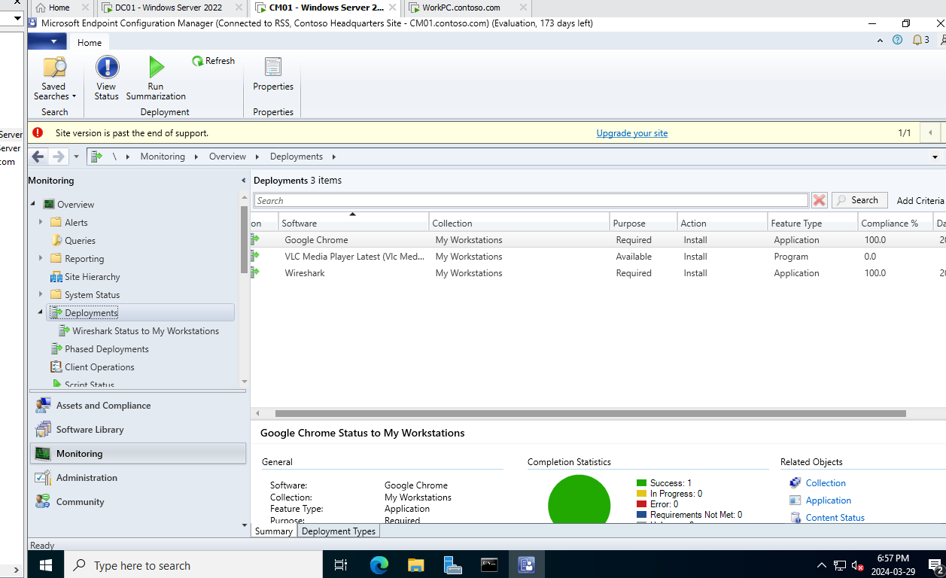

Sc-13

On the other workstation I could see the available VLC Media Player in the Software Center, ready to be installed at my convenience. (sc14, sc15)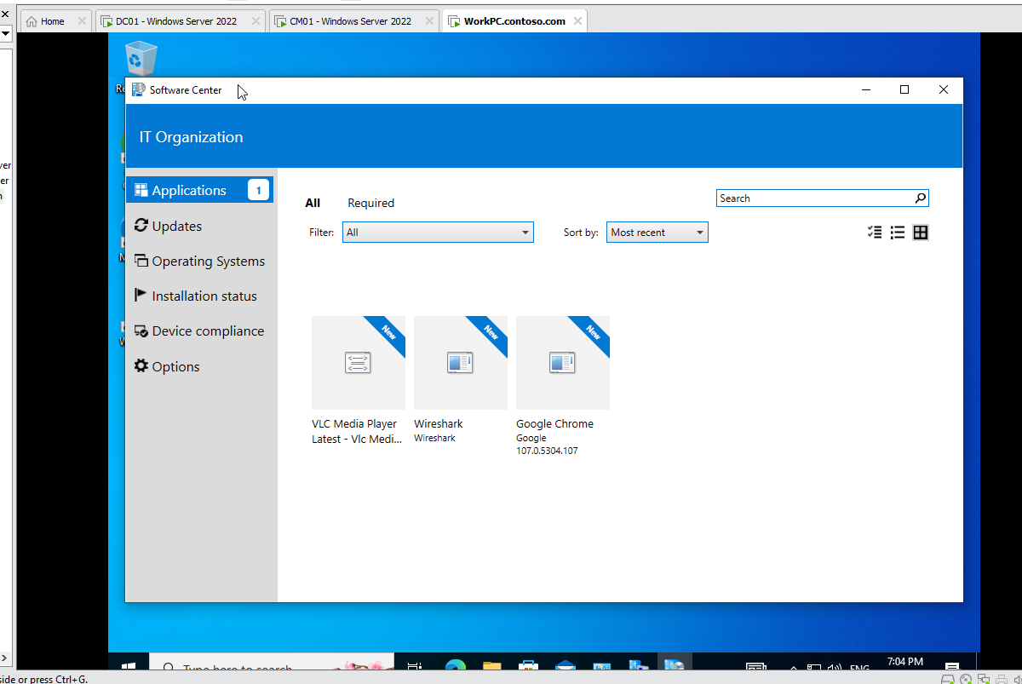

Sc-14

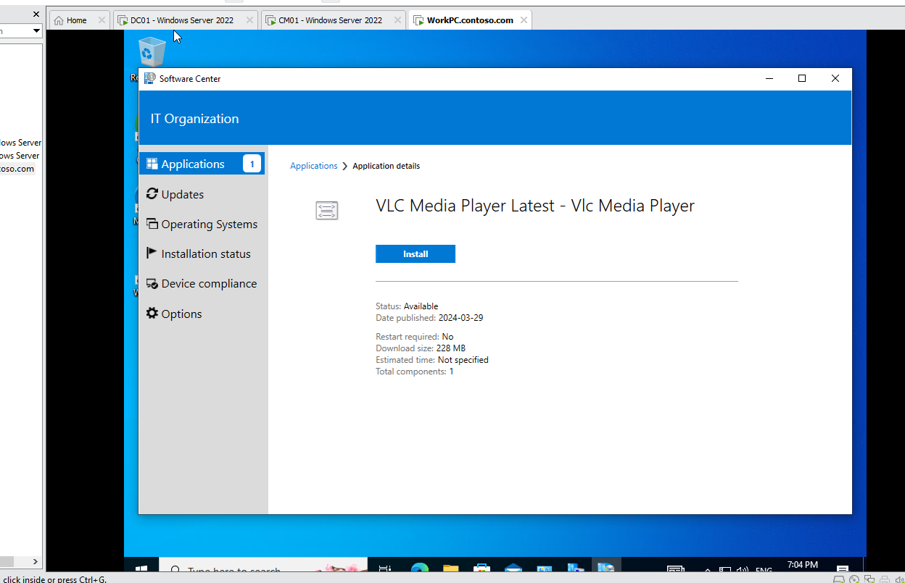

Sc-15

Deploying VLC Media Player through SCCM provides a streamlined and controlled method to ensure all users have access to a consistent media player across the organization. The entire process, from package creation to end-user availability, is managed within SCCM, simplifying the administration of software resources.

**Deploying ApacheOffice**

The first step was downloading VLC Media Player, typically from the official website, ensuring we have the correct installer package, in this case it was a .exe file. I initiated the deployment process in SCCM's Software Library, where packages are managed. A new package for Apache OpenOffice was created, leveraging the detailed settings within the ‘Create Package and Program Wizard’. This set the stage for the installation.

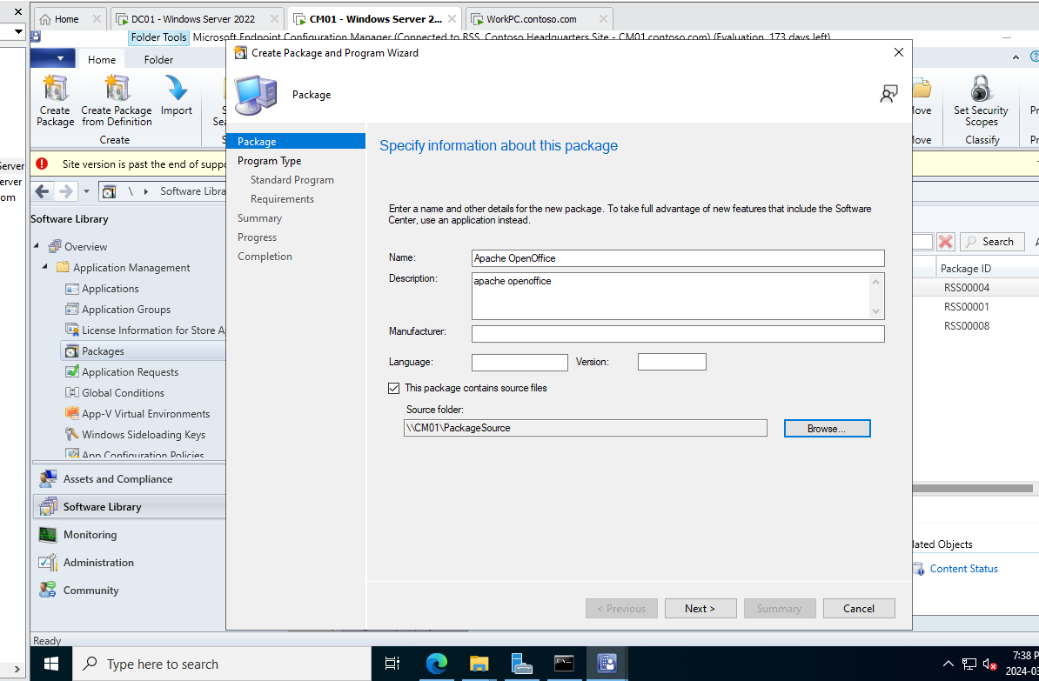

Sc-16

Moving forward, we provided specific details for Apache OpenOffice (sc3.png). This included naming the package, describing its function, and setting the language and version. These attributes are important for accurate deployment and future management within SCCM.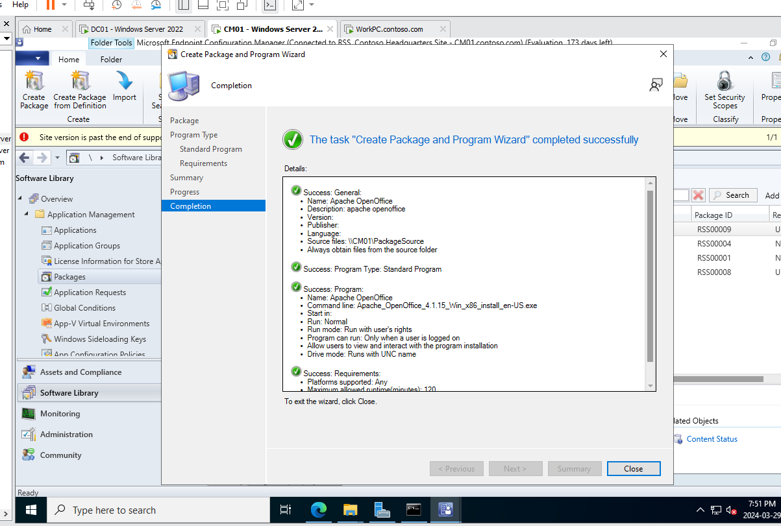

Sc-17

Next, we defined the program for Apache OpenOffice, I choose standard program, setting the command line instructions for a silent installation and specifying run conditions to ensure installations only occur when users are logged in.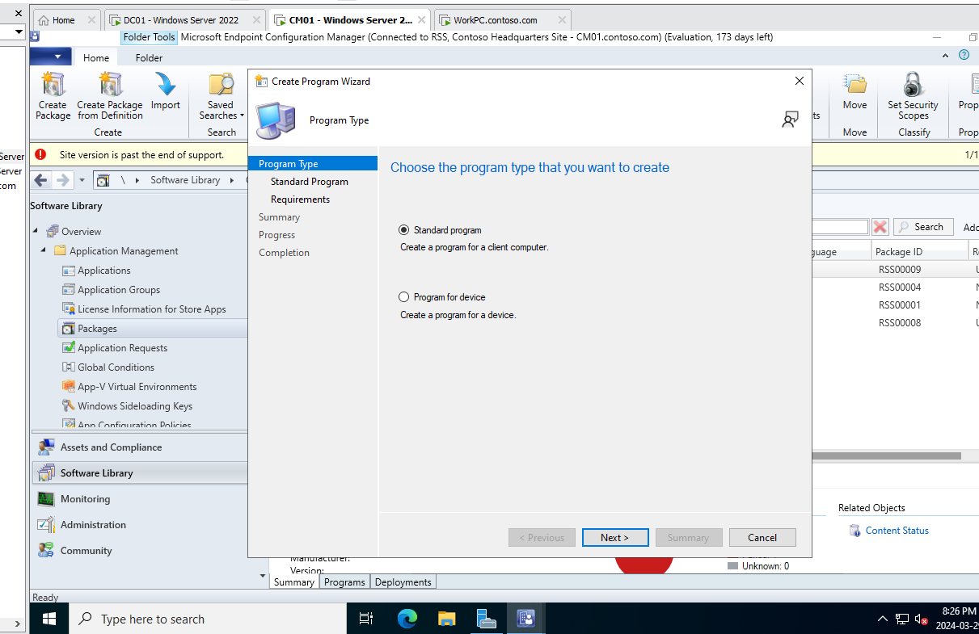

Sc-18

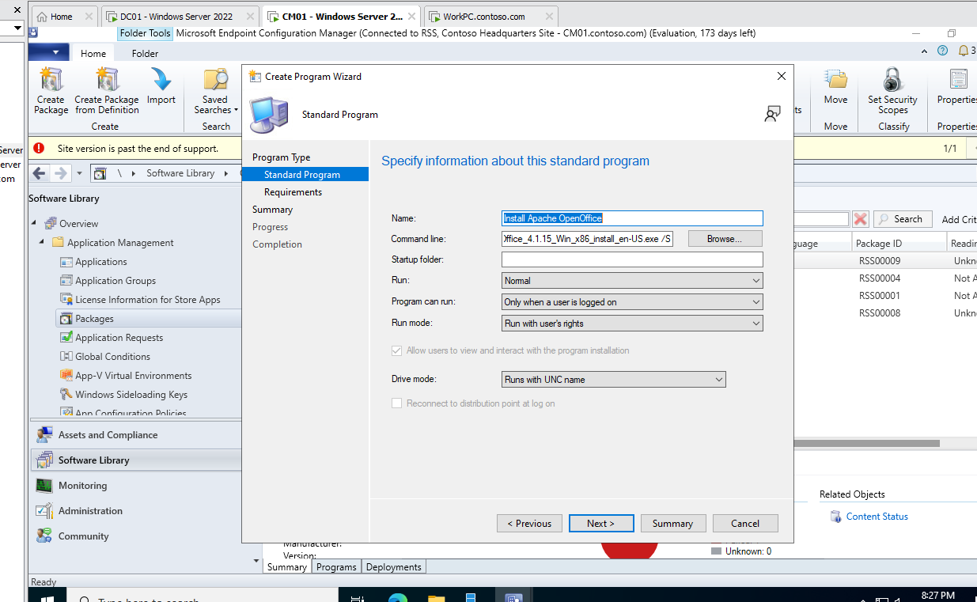

Sc-19

After that I completed the create program wizard as it was mandatory for the deployment of Apache Office.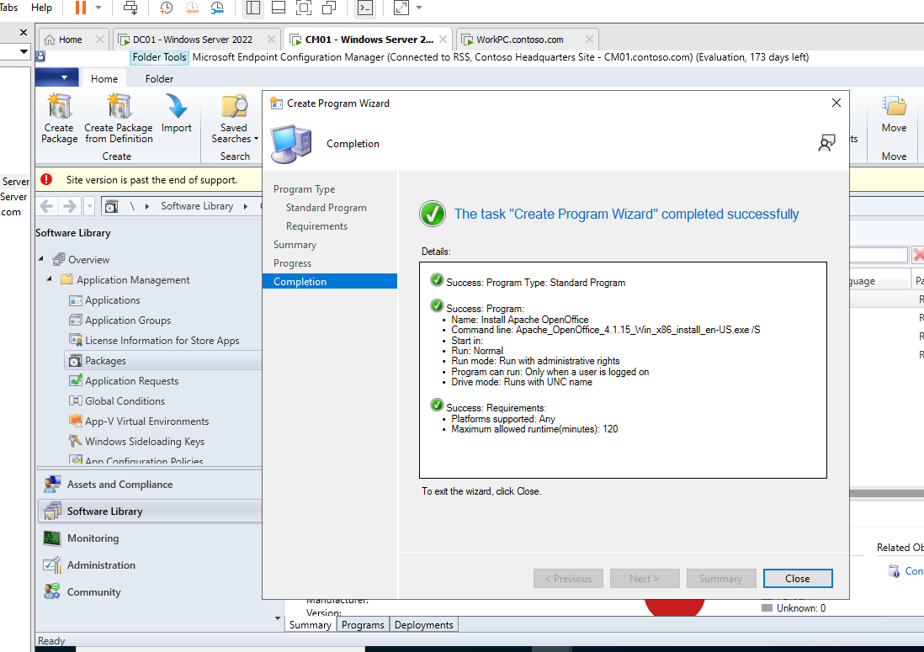

Sc-20

With the package configured, I established the deployment settings, specifying content distribution points, ensuring that the Apache OpenOffice installation files were readily accessible to the client machines 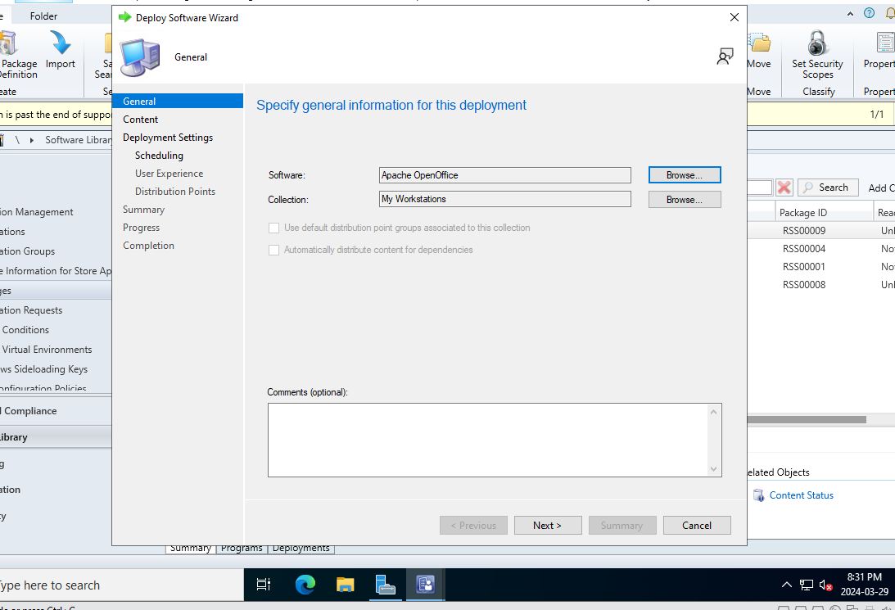

Sc-21

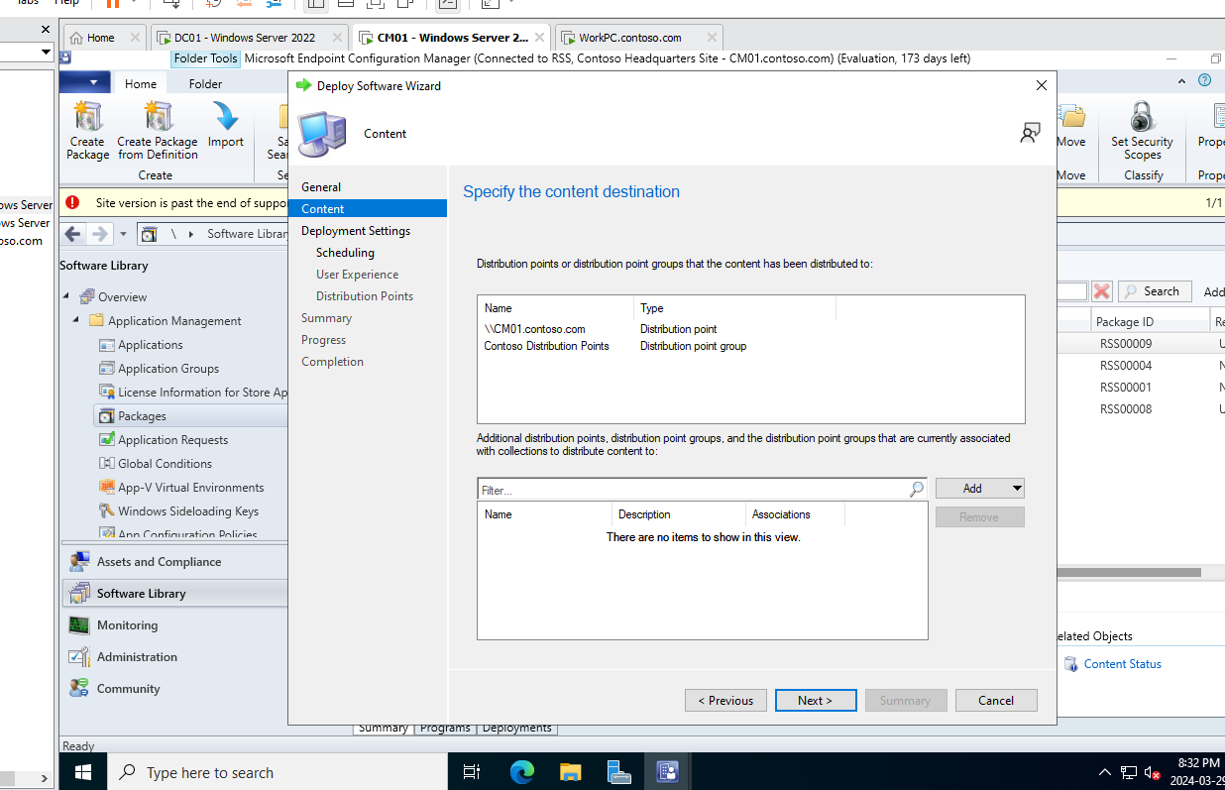

Sc-22

I also decided on a 'Required' action, which obliges the installation on all targeted machines. The scheduling was set to proceed as soon as possible, streamlining the deployment process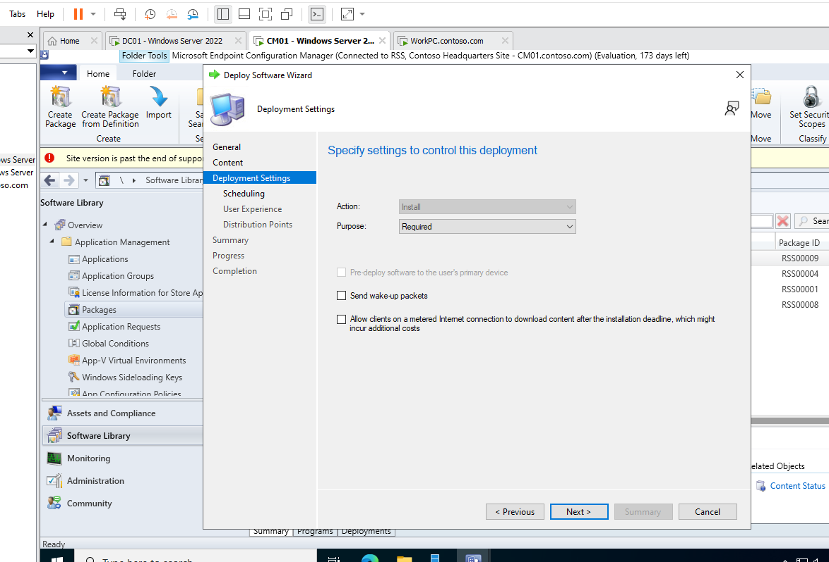

Sc-23

Prior to activation, I checked the summary just to verify my configurations. After that the successful completion of the 'Deploy Software Wizard' marked the readiness of Apache OpenOffice for network-wide distribution.

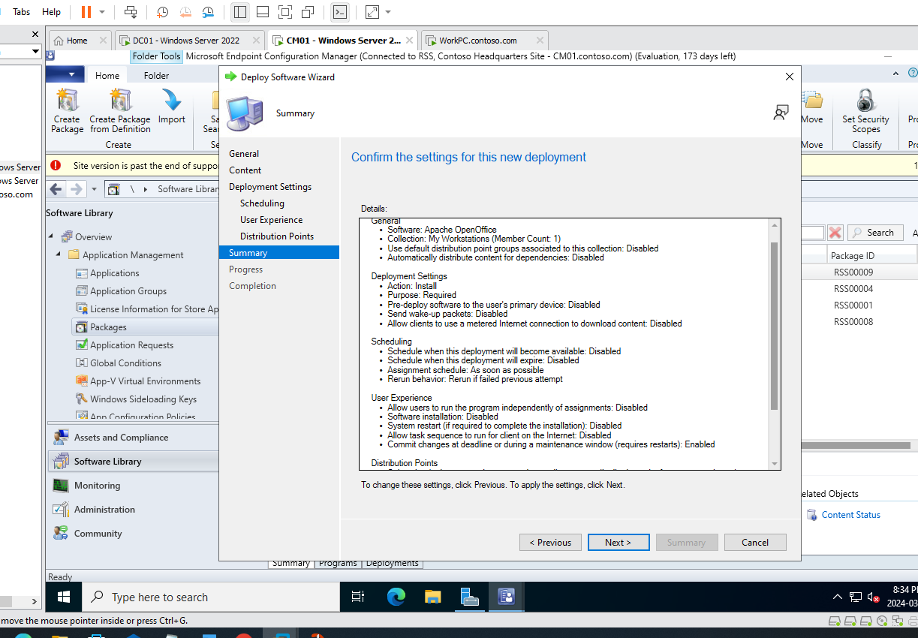

Sc-24

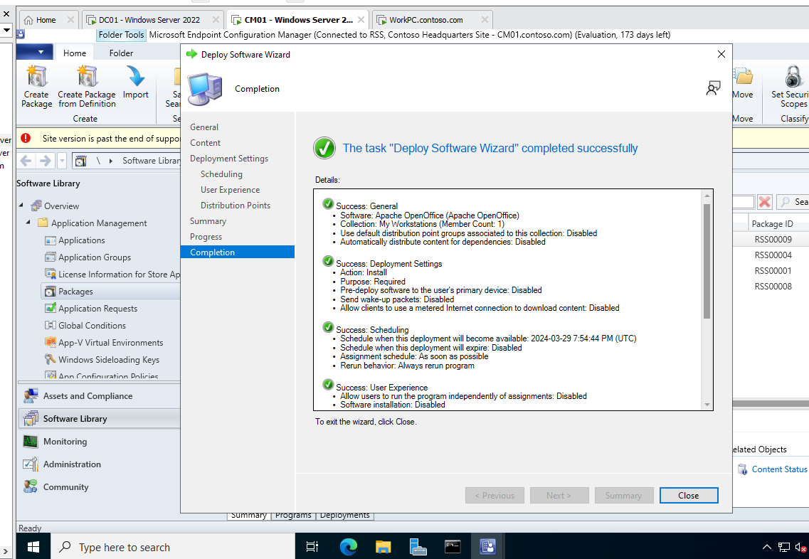

Sc-25

After successfully deploying the package, I checked the monitoring tab to monitor what’s being deployed in the system and there I can see that the Apache Office is deployed successfully

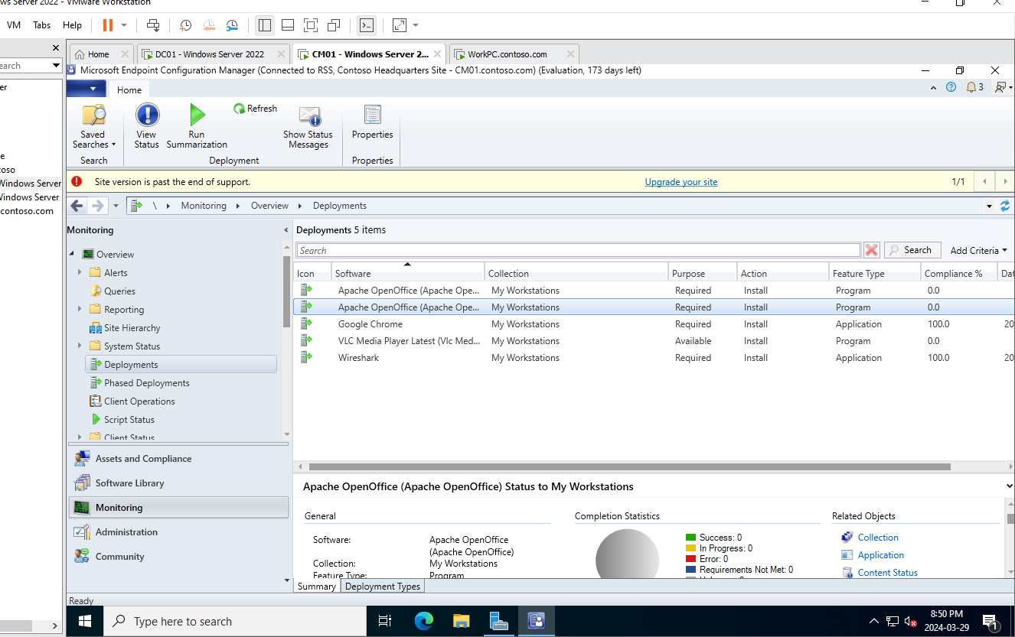

Sc-26

Also, I checked the workstation where it is supposed to be tested and I saw Apache Office icon in the desktop.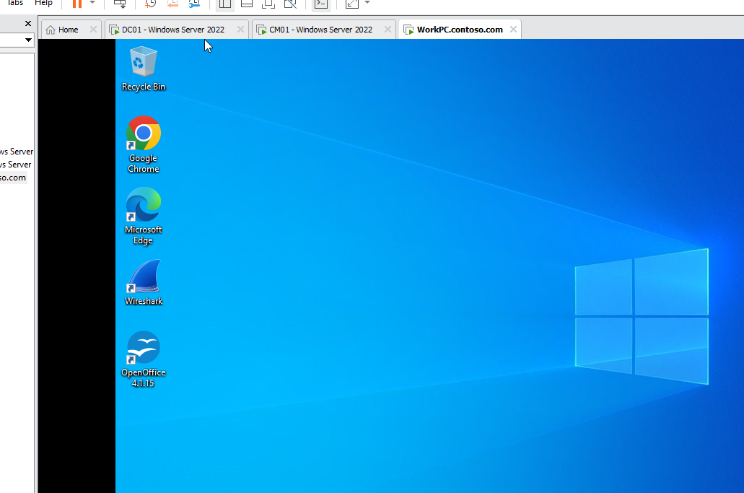

Sc-27

In the end we can see that all the applications and packages are installed in the workstation, including Wireshark, VLC media player and Apache Office.

Sc-29